**Sample output for er diagram**

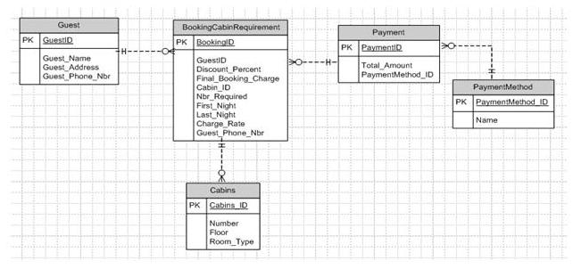

* Guest  ( GuestID,  Guest_Name,  Guest_Address,  Guest_Phone_Nbr  )
* BookingCabinRequirement ( BookingID,  GuestID,  Discount_Percent,  Final_Booking_Charge,  Cabin_ID,  Nbr_Required,  First_Night,   Last_Night,  Charge_Rate,   Guest_Phone_Nbr ) foreign key (GuestID) references Guest(GuestID)

foreign key (Cabin_ID) references Cabins(Cabin_ID )

* Cabins (Cabins_ID, Number, Floor, Room_Type)
* Payment( PaymentID, Total_Amount, PaymentMethod_ID)

foreign key (PaymentMethod_ID ) references PaymentMethod ( PaymentMethod_ID )

* PaymentMethod ( PaymentMethod_ID, Name)